Exp No:3.a) Conduct an experiment to show data visualization using line plot Aim:
To Conduct an experiment to show data visualization using line plot Description:
Take any sample data either through csv file or data fetched directly through Code:
import matplotlib.pyplot as cricket
Overs = list(range(5, 51, 5))
Indian_Score = [35, 65, 95, 135, 175, 210, 245, 285, 325, 365] Srilankan_Score = [28, 60, 85, 115, 150, 180, 205, 235, 265, 295] cricket.plot(Overs, Indian_Score, color="blue", label="INDIA") cricket.plot(Overs, Srilankan_Score, color="orange", label="SRILANKA") cricket.title("INDIA Vs SRILANKA") cricket.xlabel("Overs") cricket.ylabel("Score") cricket.legend(loc="center right") cricket.show() output:
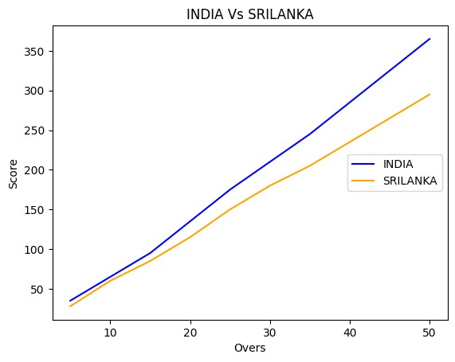
Result:
The line plot was successfully drawn comparing India and Srilanka scores over overs.India scored higher than Sri lanks throughout the match.

Exp No:3.b Conduct an experiment to show data visualization using bar chart Aim:
To conduct an experiment to shoe data visualiztaioin using bar chart.
Description:
Take any sample data either through csv file or data fetched directly through Code: import matplotlib.pyplot as hscmark import numpy as np
Names = ['ARUN', 'MEENA', 'RAJ', 'DIVYA', 'KARTHIK', 'ANU'] xaxis = np.arange(len(Names)) Percentage_hsc = [88, 76, 93, 84, 69, 97] hscmark.bar(Names, Percentage_hsc) hscmark.xticks(xaxis, Names, rotation=45) hscmark.xlabel("Names of Pupil") hscmark.ylabel("Percentage") hscmark.title("Comparison of HSC Percentage", fontsize=20, color="blue") hscmark.show() output:
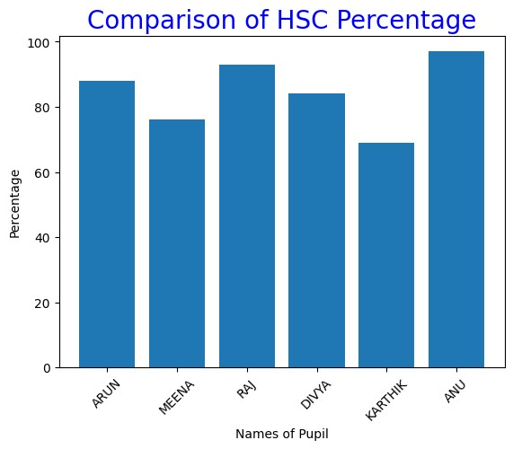
Result:
The bar chart was plotted successfully showing comparison of students’s percentage.Anu scored highest (97 %) and Karthick (69%).

Exp No:3.c) Conduct an experiment to show data visualization using pie chart.
Aim:
To conduct an experiment to show data visualization using pie chart.
Description:
Take any sample data either through csv file or data fetched directly through code.
Code:
import matplotlib.pyplot as election labels = ['ARUN', 'BHARATH', 'CHARAN', 'DEEPA'] Votes = [280, 195, 320, 155] colors = ['blue', 'pink', 'purple', 'orange'] explode = (0, 0.2, 0, 0) election.pie(Votes, labels=labels, colors=colors,explode=explode, autopct='%0.2f%%') election.title('College Election Results') election.show() output:
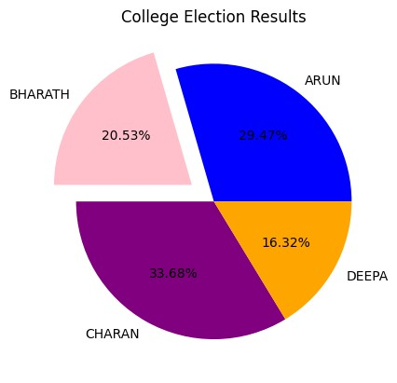
Result:
The experiment was successfully completed, and the pie chart clearly represents the given data using proper labels,colors,and proportions.

